3.1

Login

Login

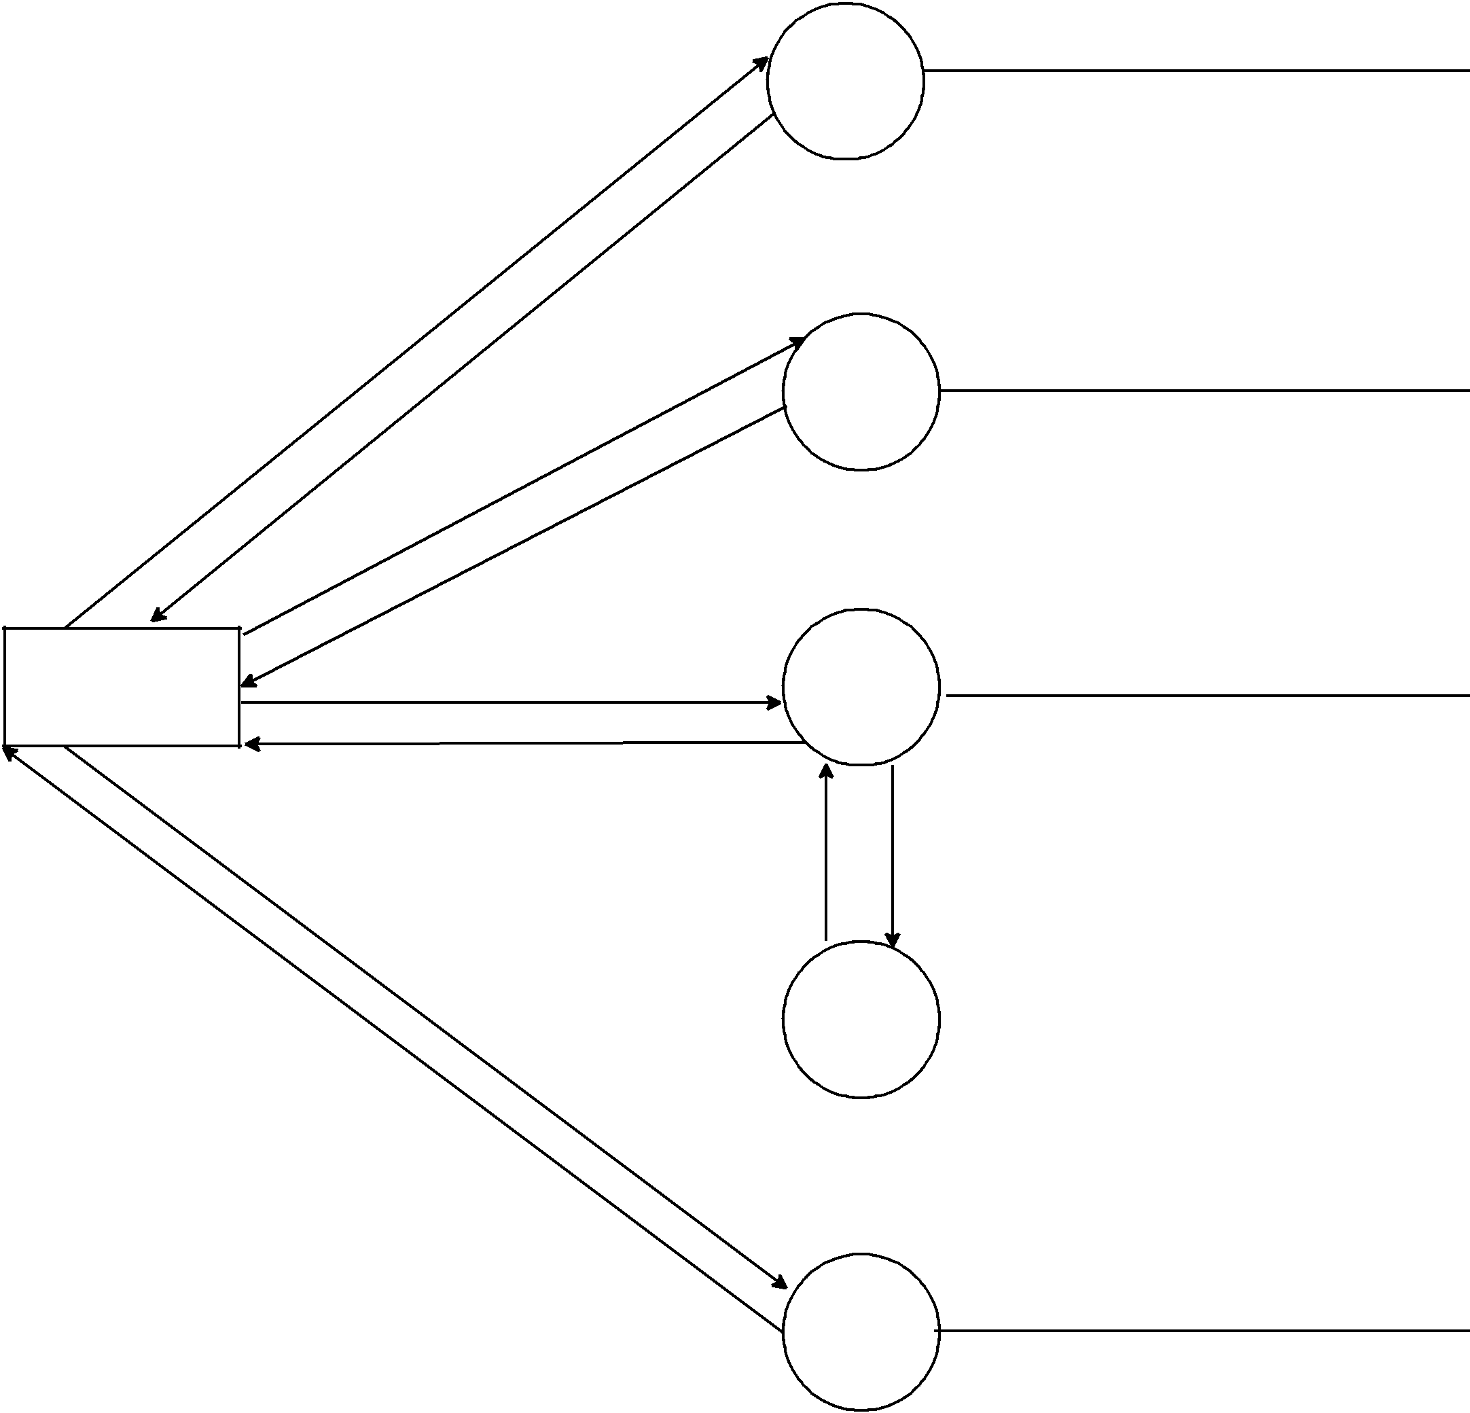

Request

Confirmation
Request

Confirmation

Request

Employee

Transaction

Done

Request

OTP

Generate

3.2

View

Reports

3.3

Create

Transaction

Information
Request
Received

3.3.1

View

Transactiom

3.4

Genrate

OTP

Customer_acc_Update

Emp_Create_Tran

Genrate_OTP

